23CSE111

OBJECT ORIENTED PROGRAMMING

LAB MANUAL


Department of Computer Science and Engineering Amrita School of computing
Amrita Vishwa Vidyapeetham, Amaravati Campus

Verified by: NAME: M. GAURAV
ROLLNO: AV.SC.U4CSE24212

S.No. | Experiment Name | Page No. | Remarks | Signature
1 | Installation Process of JDK | 3-6
2 | Simple Java Program for printing basic details of student | 6-10
3 | Simple java programs | 10-21

WEEK-1

- How to download and install java software in your computer.
1.Steps for downloading.
Step 1: Java is developed by oracle. so, open your web browser and search for java oracle.
Step 2: Then go to the website https://www.oracle.com/in/java/ .
Step 3: And navigate to the java downloads. Then some earlier versions are available like
- JDK 23
- JDK 21
- GraalVM for JDK 23
- GraalVM for JDK 21
Step 3: JDK 21 is the latest Long-Term Support (LTS) release of the Java SE Platform. So, we use this version.
Step 4: According to your device operating system choose the product/file description.
Step 5: Then the version will be automatically downloaded.
2.Steps for installation.
Step 1: Go to the folder where it was downloaded.
Step 2: Then open and accept all terms and conditions.
Step 3: And install it.

3.Setting environmental variables.
Step 1: Open file explorer, then right click on This PC next select on properties then it will take you to the settings app then click on advanced system settings and then click on Environment Variables.
Step 2: Click New under System Variables:
    - Set Variable name as: java_home
    - Variable value: The folder address where JDK is installed (like C:\Program Files\Java\jdk-21\bin)
Step 3: Find Path under System Variables, click Edit, and add the path of the jdk-21(D:\UNI+\EDU\JAVA)

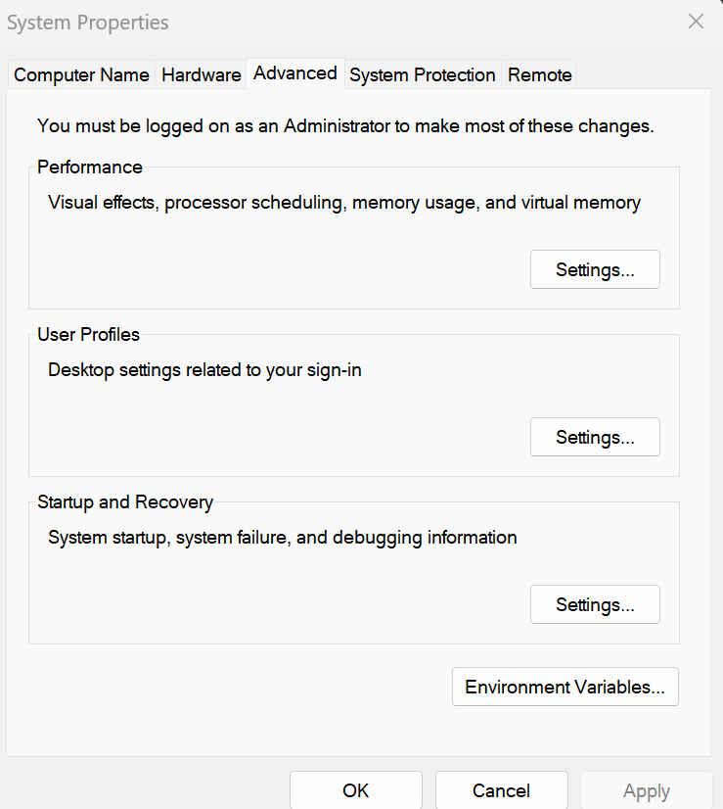

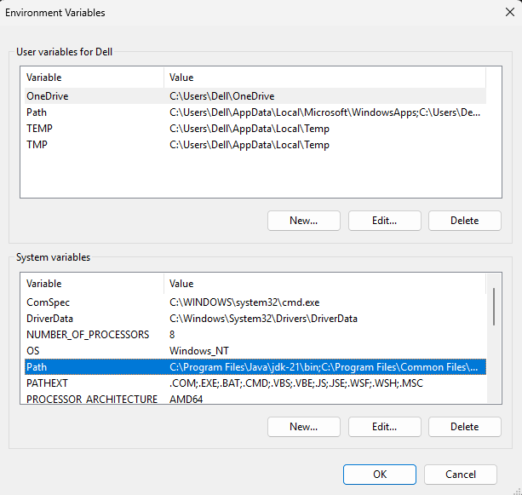

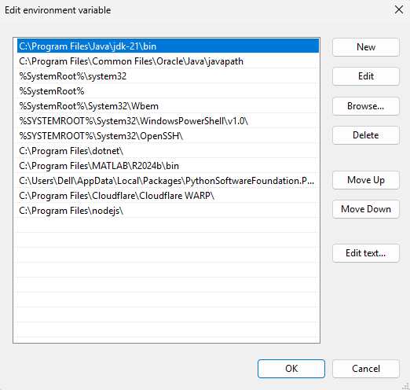
4.Checking for jdk(java development kit) version.
Step 1: Open command prompt.
Step 2: Enter javac --version for version of jdk installed.
Step 3: Enter java –version for all details like when downloaded and path of environment variables
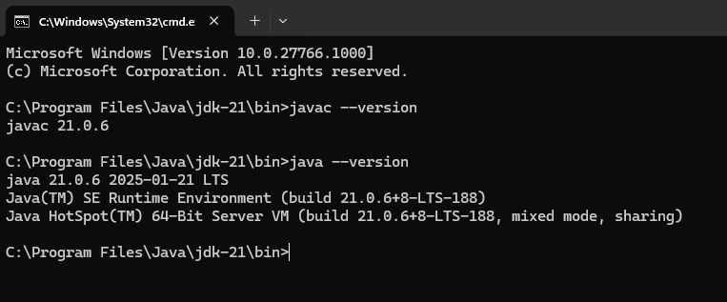
a ) write a simple java program to print your name, roll no,sec etc.

Program :

class Demo
{
public static void main(String[] args)

{
System.out.println("NAME= M. GAURAV");
System.out.println("ROLL NO= AV.SC.U4CSE24212");
System.out.println("SEC= C");
System.out.println("BRANCH= CSE");
}
}

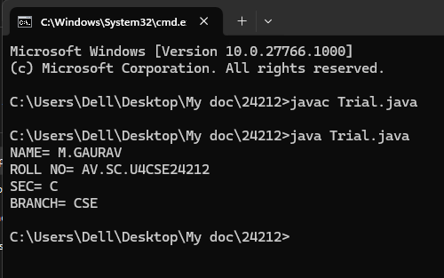
Errors:

S.NO | Error Name | Error Rectification
1 | Syntax/ Compilation Error | Trial.java:6: error: ';' expected  System.out.println("NAME= M.GAURAV")  ^  1 error

WEEK -2 (LAB)
SIMPLE JAVA programs
- WRITE A JAVA PROGRAM TO FIND AREA OF RECTANGLE
Program:
import java.util.*;
class area
{
public static void main(String args[])
{
int area;
Scanner sc = new Scanner(System.in);
System.out.println("Enter Length:");
int l = sc.nextInt();
System.out.println("Enter Breadth:");
int b = sc.nextInt();
area = l*b;
System.out.println("Area of Rectangle :"+area);
}
}

Output:
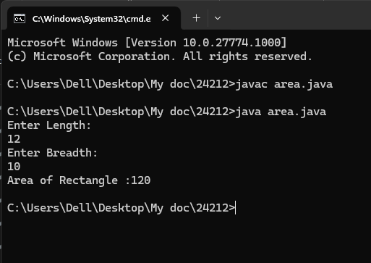
Error:
1 | Syntax error | area.java:7: error: ';' expected  Scanner sc = new Scanner(System.in)  ^  1 error

- WRITE A JAVA PROGRAM TO CALCULATE SIMPLE INTREST:

import java.util.*;
class Simpleinterest{
public static void main(String[] args)
{
System.out.println(" taking input");
Scanner sc = new Scanner(System.in);
System.out.println("enter INTa number:");
float p = sc.nextFloat();
System.out.println("enter a number:");
float t = sc.nextFloat();
System.out.println("enter a num:");
float r = sc.nextFloat();
float s = (p*t*r)/100;
System.out.println("simple intrest is"+s);
}
}
Output:
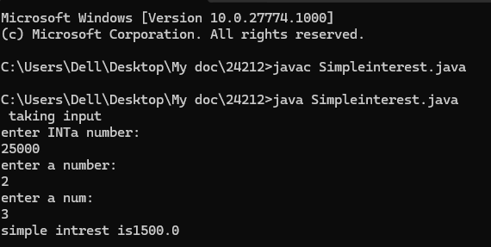

Error:
S.No | Error type | Reason for error
1 | Runtime error | error: file not found: Simpleinterest.java  Usage: javac <options> <source files>  use --help for a list of possible options

- WRITE A JAVA PROGRAM TO FIND FIBNOACCI SERIES:
Program:
import java.util.*;
class fibo
{
public static void main(String args[])
{
Scanner sc = new Scanner(System.in);
int num;
int f3;
int f1 = 0;
int f2 = 1;
int i = 2;

System.out.print("Enter a number:");
num = sc.nextInt();
System.out.println(f1);
System.out.println(f2);

while(i<num)
{
f3 = f1+f2;
f1 = f2;
f2 = f3;
System.out.println(f3);
i = i+1;
}
}
}
Output:
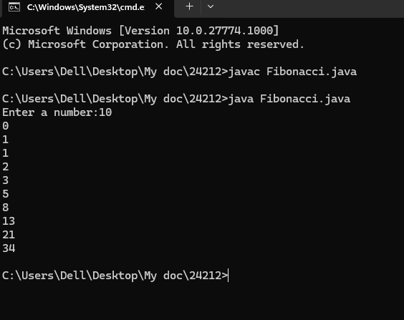
Error:
S.No | Error type | Reason for error
1 | Runtime error | error: file not found: Fibonacci.java  Usage: javac <options> <source files>  use --help for a list of possible options

- WRITE A JAVA PROGRAM TO CALCULATING TEMPERATURE IN CELSIUS
Program:
import java.util.*;
class temp
{
public static void main(String args[])
{
Scanner sc = new Scanner(System.in);
float c;
System.out.println("Enter Fahrenheit Temperature:");
float f = sc.nextFloat();
c = (f-32)*5/9;
System.out.println("celcius Temperature is :"+c);
}
}
Output:
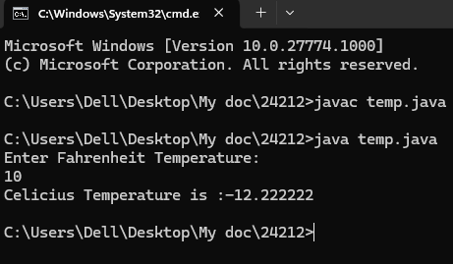
Error:
S.No | Error type | Reason for error
1. | Syntax | temp.java:7: error: ';' expected  Scanner sc = new Scanner(System.in)

- WRITE A JAVA PROGRAM TO FIND FACTORIAL OF A GIVEN NUMBER
Program:
import java.util.*;
class Fact
{
public static void main(String args[])
{
int number;
Scanner sc = new Scanner(System.in);
System.out.println("Enter a number:");
number = sc.nextInt();
System.out.println("Enter time:");
int answer = factorial(number);
System.out.println("factorial of"+ number + " is " + answer);

} static int factorial(int n){
if(n==1)
{
return 1;
}
return n * factorial(n-1);

}
}
Output:
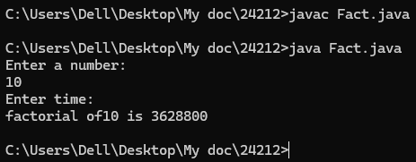

Error:
S.No | Error type | Reason for error | rectification
 | Logical error | Incorrect input | Correcting input
 | Runtime error | Incorrect path | Using correct path

- WRITE A JAVA PROGRAM TO CONVERTE CELSIUS TO FAHRENHEIT:
Program:
import java.util.*;
class heat
{
public static void main(String args[])
{
Scanner sc = new Scanner(System.in);
float f;
System.out.println("Enter Celsius Temperature:");
float c = sc.nextFloat();
f = (c*9/5)+32;
System.out.println("Fahrenheit Temperature is :"+f);
}
}
Output:
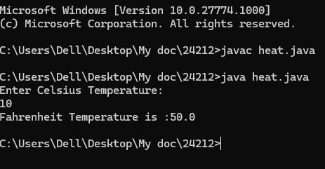
Error:

S.No | Error type | Reason for error | rectification
1. | Logical error | Incorrect input | Correcting input

- WRITE A JAVA PROGRAM TO CALCULATING AREA OF TRIANGLE USING HERONS’ FORMULA:
Program:
import java.util.*;
import java.lang.Math;

class Triangle{
public static void main(String[] args) {
double s, c, a, b, p;
Scanner sc = new Scanner(System.in);
System.out.println("Enter the value of a, b, and c:");
a = sc.nextDouble();
b = sc.nextDouble();
c = sc.nextDouble();
s = (a + b + c) / 2;
p = Math.sqrt(s * (s - a) * (s - b) * (s - c));
System.out.println("Area of triangle by Heron's formula is = " + p);
}
}

Output:
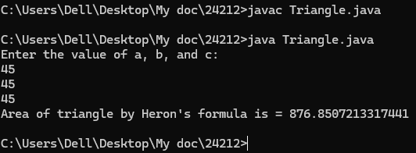
Error:

S.No | Error type | Reason for error | rectification
1. | Logical error | Incorrect input | Correcting input

WEEK -3
WRITE A JAVA PROGRAM TO CREATE A CLASS WITH CAR NAME:

PROGRAM:

class Main {
String car_color;
String car_brand;
String fuel_type;
int mileage;

// Constructor
public Main(String car_color, String car_brand, String fuel_type, int mileage) {
this.car_color = car_color;
this.car_brand = car_brand;
this.fuel_type = fuel_type;
this.mileage = mileage; // Fixed the spelling mistake here
}

// Getter methods
public String color() {
return car_color;
}

public String brand() {
return car_brand;
}

public String fuel() {
return fuel_type;
}

public int mile() {
return mileage;
}

// Main method
public static void main(String[] args) {
Main car1 = new Main("red", "Hyundai", "diesel", 19);
System.out.println("Car 1 - Color: " + car1.color() + ", Brand: " + car1.brand() +
", Fuel Type: " + car1.fuel() + ", Mileage: " + car1.mile());

Main car2 = new Main("blue", "Toyota", "petrol", 17);
System.out.println("Car 2 - Color: " + car2.color() + ", Brand: " + car2.brand() +
", Fuel Type: " + car2.fuel() + ", Mileage: " + car2.mile());

Main car3 = new Main("black", "Tata", "diesel", 19);
System.out.println("Car 3 - Color: " + car3.color() + ", Brand: " + car3.brand() +
", Fuel Type: " + car3.fuel() + ", Mileage: " + car3.mile());
}
}

Output:

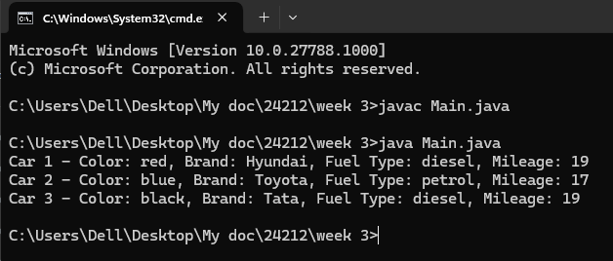
Error:

S.No | Error type | Reason for error
1. | Identifier error | Main.java:3: error: <identifier> expected  car_brand;  ^  1 error

WRITE A JAVA PROGRAM TO CREATE A CLASS BANK ACCOUNT WITH METHODS DEPOSIT AND WITHDRAWAL:

PROGRAM:
class Bank_Account {
private String accname;
private int acno;
private float balance;

// Constructor
public Bank_Account(String accname, int acno, float balance) {
this.accname = accname;
this.acno = acno;
this.balance = balance;
}

// Withdraw method
public void withdraw(int amount) {
if (amount <= balance) {
balance -= amount;
System.out.println("Withdrawal of " + amount + " successful. Remaining balance: " + balance);
} else {
System.out.println("Insufficient balance for " + accname);
}
}

// Deposit method
public void deposit(int amount) {
balance += amount;
System.out.println("Deposit of " + amount + " successful. Updated balance: " + balance);
}

// Method to display account details
public void displayDetails() {
System.out.println("Account Name: " + accname);
System.out.println("Account Number: " + acno);
System.out.println("Balance: " + balance);
}

public static void main(String[] args) {
Bank_Account s = new Bank_Account("Anil", 34571, 25000);
s.withdraw(20000);
s.deposit(2000);
s.displayDetails();

System.out.println(); // Just for better readability

Bank_Account s1 = new Bank_Account("Jeevan", 333226, 25000);
s1.withdraw(2500);
s1.deposit(250000);
s1.displayDetails();
}
}
OUTPUT:
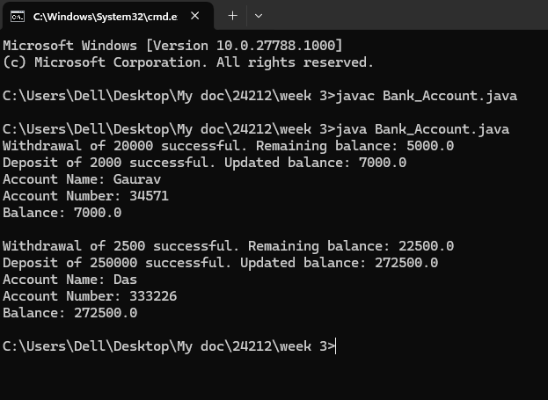
ERROR:
S.No | Error type | Reason for error
1. | Syntax | Bank_Account.java:7: error: ';' expected  Scanner sc = new Scanner(System.in)

WEEK-4
TO CREATE A JAVA PROGRAM WITH CLASS NAMED “MYCLASS” WITH A STATIC VARIABLE COUNT OF “INT” TYPE ,INSIZED TO “ZERO” AND A CONSTANT VARIABLE “PI” OF TYPE “DOUBLE” INITIALIZED TO 3.1415 AS ATTRIBUTES OF THAT CLASS . DEFINE A CONTRUCTOR FOR “MYCLASS” IS CREATED FINALLY PRINT THE FINAL VALUES “COUNT” AND “PI” VARIABLES.
CLASS DIAGRAM
MyClass
- count: int (static)
- pi: double (static final)

+ MyClass()
+ main(String[] args): void

PROGRAM:
public class MyClass {
public static int count = 0;
public static final double PI = 3.14;

public MyClass() {
count++;
}

public static void main(String[] args) {
MyClass obj1 = new MyClass();
MyClass obj2 = new MyClass();
MyClass obj3 = new MyClass();

System.out.println("Count: " + count);
System.out.println("PI: " + PI);
}
}
OUTPUT:
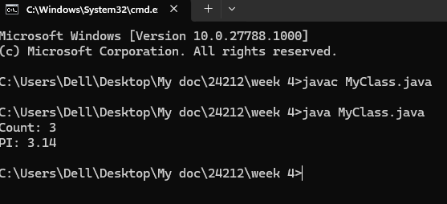
Error:
S.No | Error type | Reason for error
1. | Syntax | MyClass.java:7: error: ';' expected  Scanner sc = new Scanner(System.in)

TO CREATE A JAVA PROGRAM WITH CLASS NAMED” BOOK”. THE CLASS SHOULD CONTAIN VARIOUS ATTRIBUTES SUCH AS “TITLE OF THE BOOK”, “AUTHOR”, YEAR OF PUBLICATIONS”, IT SHOULD ALSO CONTAIN A CONSTRUCTOR WITH PARAMETER WHICH INITIALIZES “TITLE OF THE BOOK”, “AUTHOR”, “YEAR OF PUBLICATION”. CREATE A METHOD WHICH DISPLAYS THE DETAILS OF THE BOOK. TITLE OF THE BOOK (), AUTHOR (), YEAR OF PUBLICATION ().DISPLAY THE DETAILS OF TWO BOOK, BY CREATING 2 OBJECTS.
CLASS DIAGRAM
Book
- title: String
- author: String
- year: int
Book(String, String, int)
+ displayDetails(): void

PROGRAM:
class book{
public String title;
public String author;
public int year_of_publication;

public book(String title, String author, int year_of_publication){
this.title = title;
this.author = author;
this.year_of_publication = year_of_publication;
}

public void printbookDetails(String title, String author, int year_of_publication){
System.out.println("Title of book: " + title);
System.out.println("Author for this book: " + author);
System.out.println("Year of publication: " + year_of_publication);
}

public static void main(String[] args){
book book = new book("Harry Potter", "J.K.Rowling", 2001);
book.printbookDetails(book.title, book.author, book.year_of_publication);
}
}

OUTPUT:
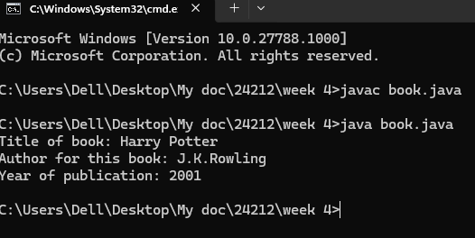
Error:
S.No | Error type | Reason for error
1 | Runtime error | error: file not found: book.java  Usage: javac <options> <source files>  use --help for a list of possible options

WEEK -5
1)AIM: Create a calculator using the operations including addition, subtraction, multiplication and division using Multilevel Inheritance and display the desired output.
Class Diagram:

Calculator
- a: double
- b: double
+ Calculator(double, double)
+ add(): double
+ subtract(): double
+ multiply(): double
+ divide(): double
+ displayResults(): void

Program:
class addition
{
public int add(int a, int b)
{
int addition = a+b;
return addition;
}
}
class subtraction extends addition
{
public int sub(int a, int b)
{
int subtraction = a-b;
return subtraction;
}
}
class multiplication extends subtraction
{
public int mult(int a, int b)
{
int multiplication = a*b;
return multiplication;
}
}
class division extends multiplication
{
public int div(int a,int b)
{
int division = a/b;
return division;
}
}
class calculator
{
public static void main(String args[])
{
division obj = new division();
System.out.println("Addition is:"+ obj.add(10,2));
System.out.println ("Subtraction is:"+obj.sub(8,4));
System.out.println("Multiplication is:"+obj.mult(12,4));
System.out.println("Division is:"+obj.div(8,4));

}
}

Output:
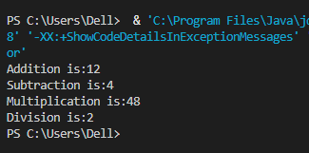

Error:
S.No | Error type | Reason for error
1. | Syntax | Bsec.java:23:error:illegal character:’\u00a0

Important Points:-
Inheritence:
The concept of OOP where a class inherits the properties and behaviours from
Another class (parent class) which promotes code reusability and hieratchical relationships

Multilevel Inheritence:
This is a type of inheritance in which a class inherited from another class, and
That superclass, in turn, inherits from yet another class, creating a chain of
Inheritance

2) AIM: A vehicle rental company wants to develop a system that maintains information about different types of vehicles available for rent. The company rents out cars and bikes and they need a program to store details about each vehicle such as brand and speed
• Cars should have an additional property: number of doors
• Bike should have a property indicating whether they have gears or not
• The system should also include a function to display details about each vehicle and indicate when a vehicle is starting
• Every class should have a constructor
1. Which OOP concept is used in the above program? Explain why it is useful in this scenario.
2. If the company decides to add a new type of vehicle truck, how would you modify the program? Truck should include an additional property capacity(in tons). Create a showTruckDetails() method to display the truck’s capacity. Write a constructor for truck that initializes all properties.
3. Implement the truck class and update the main method to create a truck object, also create an object for car and bike subclassed. Finally display its details.

Program:
class Vehicle {
String brand;
int speed;

public Vehicle(String brand, int speed) {
this.brand = brand;
this.speed = speed;
}

public static void main(String[] args) {
Car obj1 = new Car("Ford", 34, 4);
Bike obj2 = new Bike("Hero", 100, true);
Truck obj3 = new Truck("Tata", 60, 40);
}
}

class Car extends Vehicle {
int noOfDoors;

public Car(String brand, int speed, int noOfDoors) {
super(brand, speed);
this.noOfDoors = noOfDoors;
System.out.println("Brand of car is: " + brand);
System.out.println("Speed of car is: " + speed);
System.out.println("No of doors of car: " + noOfDoors);
}
}

class Bike extends Vehicle {
boolean gears;

public Bike(String brand, int speed, boolean gears) {
super(brand, speed);
this.gears = gears;
System.out.println("Brand of bike is: " + brand);
System.out.println("Speed of bike is: " + speed);
System.out.println("Gears of bike: " + gears);
}
}

class Truck extends Vehicle {
int weight;

public Truck(String brand, int speed, int weight) {
super(brand, speed);
this.weight = weight;
System.out.println("Brand name is: " + brand);
System.out.println("Speed of Truck is: " + speed);
System.out.println("Weight of load is: " + weight);
}
}

Output:
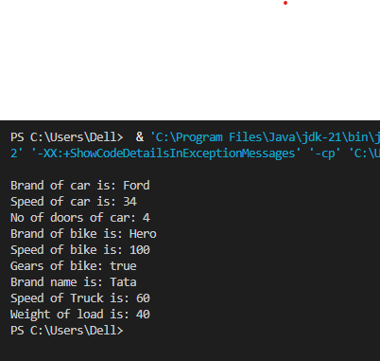
ERROR TABLE:-
S No | Error Type | Cause | Rectification
1 | Syntax Error | Semicolon missing | Added ;

Important Points
Hierarchical Inheritence:
This is a type of inheritance occurs when multiple subclasses inherit from a
Single parent class

ERROR:

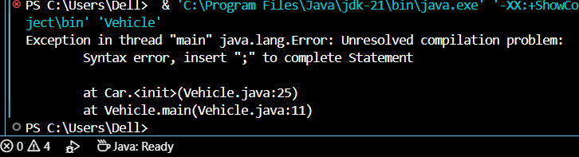
WEEK- 6
1)AIM: Write a java program to create a Vehicle class with a method displayInfo(). Override this method in the Car subclass to provide specific information about a car.
Class Diagram:
Vehicle
+ displayInfo(): void

Car
- make: String
- model: String
- year: int
+ Car(String, String, int)
+ displayInfo

Program:
class vehicle{
String company;
String model;
String fuel;
int capacity;
void displayInfo(String company,String model,String fuel,int capacity){
System.out.println("The details of vehicle: ");
this.company=company;
this.model=model;
this.fuel=fuel;
this.capacity=capacity;
}
}

class car extends vehicle{

void displayInfo(String company,String model,String fuel,int capacity){
System.out.println("Company: "+company);
System.out.println("Model: "+model);
System.out.println("Fuel: "+fuel);
System.out.println("Capacity: "+capacity);
}
}
class poly1{
public static void main(String[] args){
car car1=new car();
car1.displayInfo("Audi","Model","Diesel",4);
}
}
Output:
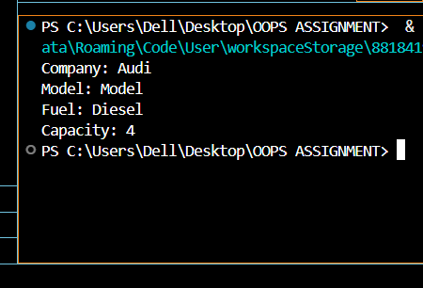
NEGATIVE CASE:

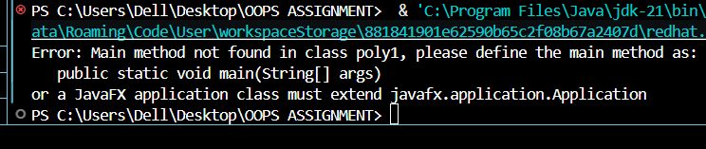

ERRORS :
S.No | Error type | Reason for error | Rectification
1 | Syntax error | [] is missed | [] is added
2 | Logical error | Incorrect logic | Correct logic

2) A college is developing an automated admission system that verifies students eligibility for undergraduate(UG) and postgraduate(PG) programs. Each program has different eligibility criteria based on the student's percentage in their previous qualification.
UG Admissions require a minimum of 60%.
PG Admissions require a minimum of 70%.

Class Diagram:
Student
- name: String
- percentage: double
+ Student(String, double)
+ getName(): String
+ getPercentage(): double

AdmissionSystem
+ isEligibleForUG(Student): boolean
+ isEligibleForPG(Student): boolean

AdmissionSystemDemo
+ main(S

Program:
class College{
String name;
int percentage;
void geteligibility(String name,int percentage){
this.name=name;
this.percentage=percentage;
}
}
class UG extends College{
void geteligibility(String name,int percentage){
if (percentage>=60){
System.out.println(name+" is eligible");
}
else{
System.out.println(name+" is not eligible");
}
}
}
class PG extends College{
void geteligibility(String name,int percentage){
if (percentage>=70){
System.out.println(name+" is eligible");
}
else{
System.out.println(name+" is not eligible");
}
}
}
class poly2{
public static void main(String[] args){
UG ug=new UG();
ug.geteligibility("Person-1",40);
PG pg=new PG();
pg.geteligibility("Person-2",80);
}
}

Output:
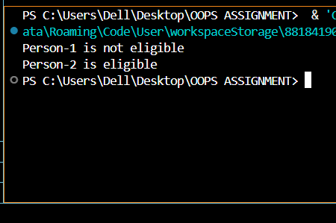
NEGATIVE CASE:
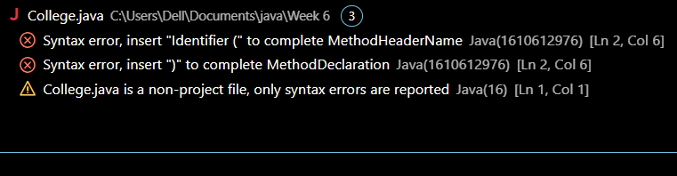

ERROR :
S.No | Error type | Reason for error | Rectification
1 | syntax error | String forgot in main function | String is added
2 | Logical error | Incorrect logic | Correct logic

3) AIM: Create a Calculator class with overloaded methos to perform addition:
i) Add two integers
ii) Add two doubles
iii) Add three integers
Class Diagram:
Calculator
+ add(int, int): int
+ add(double, double): double
+ add(int, int, int): int

CalculatorDemo
+ main(String[]): void

Program:
class Calcee{

public int add(int a,int b){
return a+b;
}
public double add(double a,double b){
return a+b;
}
public int add(int a,int b,int c){
return a+b+c;
}
}
class poly3{
public static void main(String[] args){
Calcee C1=new Calcee();
System.out.println("Sum of 2 and 5 is: "+C1.add(2,5));
System.out.println("Sum of 3.2 and 6.5 is: "+C1.add(3.2,6.5));
System.out.println("Sum of 2,5 and 3 is: "+C1.add(2,5,3));
}
}
OUTPUT :
POSITIVE CASE:

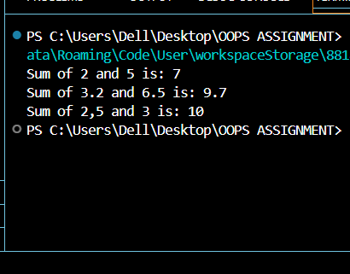

NEGATIVE CASE:

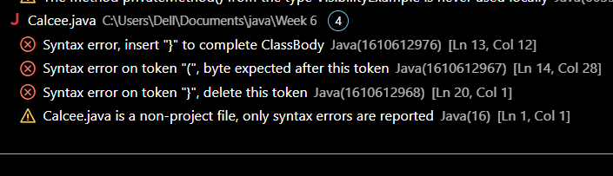

ERROR :
S.No | Error type | Reason for error | Rectification
1 | syntax error | String forgot in main function | String is added
2 | Logical error | Incorrect logic | Correct logic

4)AIM: Create a shape class with a method calculateArea() that is overloaded for different shapes (e.g square,rectangle). Then create a subclass Circle that overrides the calculteArea().
Class Diagram:
Shape
+ calculateArea(double): double
+ calculateArea(double, double): double

Circle
+ calculateArea(double): double

ShapeDemo
+ main(String[]): void

Program:
class Shape {
public double calculateArea(double side) {
return side * side; // Area of square = side^2
}

public double calculateArea(double length, double width) {
return length * width; // Area of rectangle = length * width
}
}
class Circle extends Shape {
@Override
public double calculateArea(double radius) {
return Math.PI * radius * radius; // Area of circle = π * radius^2
}
}

public class ShapeDemo {
public static void main(String[] args) {
Shape shape = new Shape();
Circle circle = new Circle();
double squareArea = shape.calculateArea(4.0);
System.out.println("Area of square (side = 4.0): " + squareArea);
double rectangleArea = shape.calculateArea(5.0, 3.0);
System.out.println("Area of rectangle (length = 5.0, width = 3.0): " + rectangleArea);
double circleArea = circle.calculateArea(3.0);
System.out.println("Area of circle (radius = 3.0): " + circleArea);
System.out.println("\nDeveloped by Gaurav");
}
}

Output:
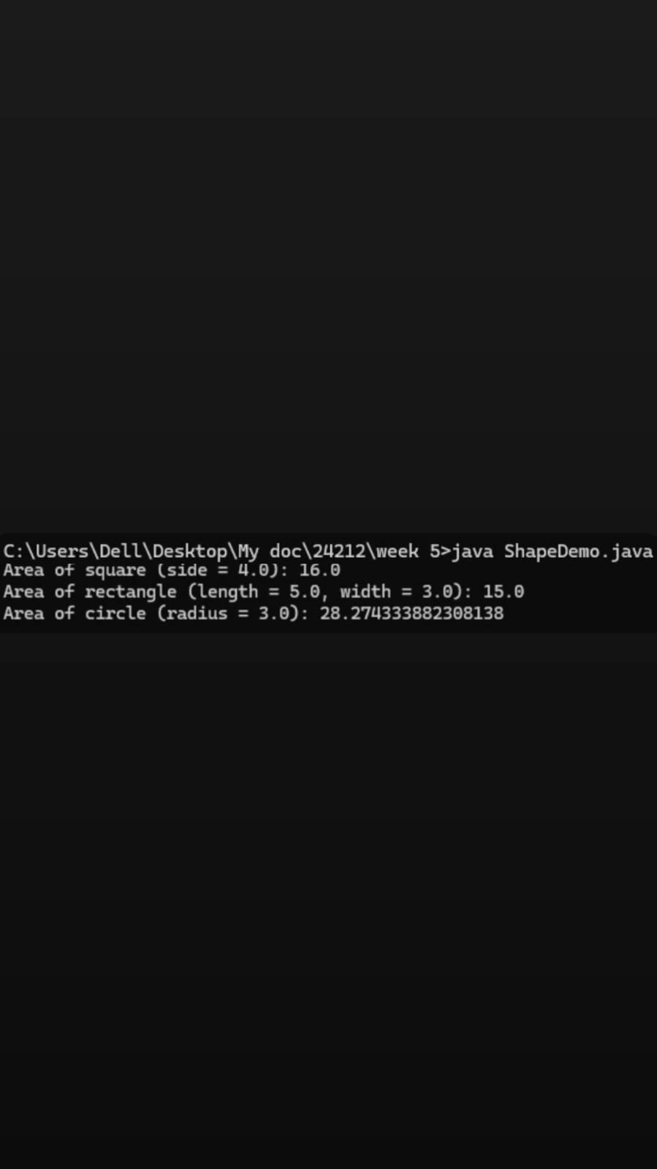

WEEK -7
1) AIM:Write a java program to create an abstract class animal with an abstract method called sound(). Create subclasses Lion Tiger that extend the Animal class and implement the sound() method to make a specific sound for each animal.
Class diagram:
<<abstract>>
Animal
+ sound(): void

Tiger Lion

+ sound(): void + sound(): void

Program:
abstract class Animal {

public abstract void sound();
}
class Tiger extends Animal {

@Override
public void sound() {
System.out.println("Tiger growls");
}
}

class Lion extends Animal {

@Override
public void sound() {
System.out.println("Lion roars");
}
}

public class Main1 {
public static void main(String[] args) {
Animal tiger = new Tiger();
Animal lion = new Lion();
tiger.sound();
lion.sound();

System.out.println("Developed by gaurav");
System.out.println("AV.SC.U4CSE24212");
System.out.println("CSE-C");
}
}
Output:
Positive Case:
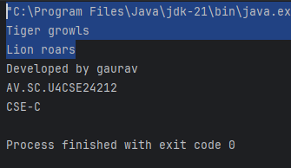
Negative Case:
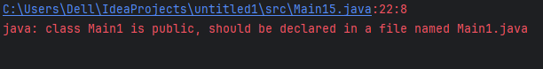

Error Table:
S NO: | ERROR | RECTIFICATION
1 | error: ‘;’ | Kept it.

Important Points:
1. Abstract Class: `Animal` is an abstract class with an abstract method `sound()`, which must be implemented by subclasses.
2. Inheritance: `Tiger` and `Lion` are concrete classes that extend the `Animal` class, providing specific implementations of the `sound()` method.
3. Method Implementation: `Tiger` implements `sound()` to print "Tiger growls", while `Lion` implements it to print "Lion roars".
4. Polymorphism: The code demonstrates polymorphism by allowing `Animal` references to point to `Tiger` and `Lion` objects.
5. Encapsulation: The classes encapsulate behavior related to different animal sounds, promoting code reusability and organization.

2)AIM: Write a Java program to create an abstract class Shape3D with abstract methods calculateVolume() and calculateSurfaceArea(). Create subclasses Sphere and Cube that extend the Shape3D class and implement the respective methods to calculate the volume and surface area of each shape.

Class Diagram:
<<abstract>>
Shape3D

+ calculateVolume(): double
+ calculateSurfaceArea(): double

Sphere Cube
- radius: double - side: double
+ calculateVolume(): + calculateVolume():
double double
+ calculateSurfaceArea(): + calculateSurfaceArea():
double double

Program:
abstract class Shape3D {

public abstract double calculateVolume();

public abstract double calculateSurfaceArea();
}

class Sphere extends Shape3D {
private double radius;

public Sphere(double radius) {
this.radius = radius;
}

@Override
public double calculateVolume() {
return (4.0 / 3.0) * Math.PI * Math.pow(radius, 3);
}

@Override
public double calculateSurfaceArea() {
return 4 * Math.PI * Math.pow(radius, 2);
}
}

class Cube extends Shape3D {
private double side;

public Cube(double side) {
this.side = side;
}

@Override
public double calculateVolume() {
return Math.pow(side, 3);
}

@Override
public double calculateSurfaceArea() {
return 6 * Math.pow(side, 2);
}
}

public class Main2 {
public static void main(String[] args) {
// Create a Sphere with radius 5
Shape3D sphere = new Sphere(5);
System.out.println("Sphere Volume: " + sphere.calculateVolume());
System.out.println("Sphere Surface Area: " + sphere.calculateSurfaceArea());

// Create a Cube with side length 3
Shape3D cube = new Cube(3);
System.out.println("Cube Volume: " + cube.calculateVolume());
System.out.println("Cube Surface Area: " + cube.calculateSurfaceArea());
System.out.println("Developed by Gaurav");
System.out.println("AV.SC.U4CSE24212");
System.out.println("CSE-C");
}
}

Output:
Positive Case:
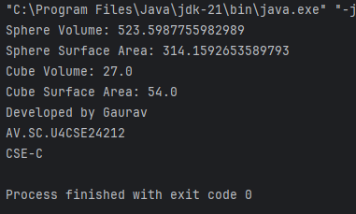
Negative Case:

Error Table:
S NO | ERROR | RECTIFICATION
1 | public static void main(String[] args) | public static void main(String[] args){

Important Points:
1. Abstract Class: `Shape3D` is an abstract class that defines two abstract methods: `calculateVolume()` and `calculateSurfaceArea()`, which must be implemented by subclasses.
2. Concrete Classes: `Sphere` and `Cube` are concrete classes that extend `Shape3D`, each providing specific implementations for calculating volume and surface area.
3. Sphere Implementation: The `Sphere` class has a private attribute `radius` and implements the volume formula (4/3 pi r^3) and surface area formula (4 pi r^2).
4. Cube Implementation: The `Cube` class has a private attribute `side` and implements the volume formula (side^3) and surface area formula ( 6*side^2).
5. Polymorphism: The code demonstrates polymorphism by allowing `Shape3D` references to point to `Sphere` and `Cube` objects, enabling dynamic method invocation for volume and surface area calculations.
3)AIM: Write a Java program using an abstract class to define a method for pattern printing.
Create an abstract class named PatternPrinter with an abstract method printPattern(int n) and a concrete method to display the pattern title.
Implement two subclasses:
1.StarPattern- Prints a right angled triangle stars
2.NumberPateern-Prints a right angled triangle increasing number
IN the main() method create objects of both subclasses and print the pattern for a given number of rows.
Class Diagram:
<<abstract>>
PatternPrinter

+ displayTitle(title: String): void
+ printPattern(n: int): void [abstract]

StarPattern NumberPattern

+ printPattern(n: int): void + printPattern(n: int): void

Program:

abstract class PatternPrinter {

public void displayTitle(String title) {
System.out.println(title);
}

public abstract void printPattern(int n);
}

class StarPattern extends PatternPrinter {
@Override
public void printPattern(int n) {
for (int i = 1; i <= n; i++) {
for (int j = 1; j <= i; j++) {
System.out.print("* ");
}
System.out.println();
}
}
}

class NumberPattern extends PatternPrinter {
@Override
public void printPattern(int n) {
for (int i = 1; i <= n; i++) {
for (int j = 1; j <= i; j++) {
System.out.print(j + " ");
}
System.out.println();
}
}
}

public class Main3 {
public static void main(String[] args) {
int rows = 5; // Number of rows for the patterns
PatternPrinter starPattern = new StarPattern();
starPattern.displayTitle("Star Pattern:");
starPattern.printPattern(rows);
PatternPrinter numberPattern = new NumberPattern();
numberPattern.displayTitle("Number Pattern:");
numberPattern.printPattern(rows);
System.out.println("Developed by gaurav");
System.out.println("AV.SC.U4CSE24212");
System.out.println("CSE-C");
}
Output:
Positive Case:
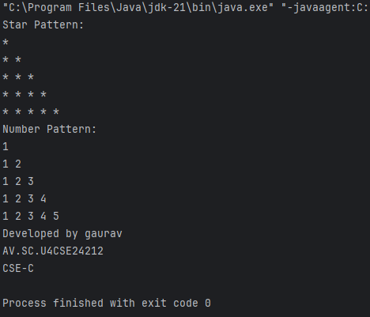

Negative Case:
Error Table:
S NO | ERROR | RECTIFICATION
1 | System.out.println() | System.out.println();

Important Points:
1. Abstract Class: `PatternPrinter` defines an abstract method `printPattern(int n)` for printing patterns and a concrete method `displayTitle(String title)` for displaying the pattern title.
2. StarPattern Class: This subclass implements `printPattern(int n)` to print a right-angled triangle of stars based on the specified number of rows.
3. NumberPattern Class: This subclass implements `printPattern(int n)` to print a right-angled triangle of increasing numbers, also based on the specified number of rows.
4. Main Method: The `main()` method creates instances of `StarPattern` and `NumberPattern`, calls `displayTitle()` to print titles, and invokes `printPattern()` to display the respective patterns.
5. Output: The program outputs a star pattern and a number pattern for a given number of rows, demonstrating the use of abstract classes and method overriding in Java.

WEEK-8
1)AIM: Write a JAVA program to create an interface Shape with the getPerimeter() method. Create three classes Rectangle, Circle and Triangle that implement the shape interface. Create three getPerimeter() method for each of the three classes.
Class Diagram:

Shape

+ getPerimeter(): double

Rectangle Circle Triangle

-width -radius -side1
-height -side2
-side3

Program:
interface Shape {
double getPerimeter();
}
class Rectangle implements Shape {
private double width;
private double height;

public Rectangle(double width, double height) {
this.width = width;
this.height = height;
}

@Override
public double getPerimeter() {
return 2 * (width + height);
}
}
class Circle implements Shape {
private double radius;

public Circle(double radius) {
this.radius = radius;
}

@Override
public double getPerimeter() {
return 2 * Math.PI * radius;
}
}
class Triangle implements Shape {
private double side1;
private double side2;
private double side3;

public Triangle(double side1, double side2, double side3) {
this.side1 = side1;
this.side2 = side2;
this.side3 = side3;
}

@Override
public double getPerimeter() {
return side1 + side2 + side3;
}
}
public class Main14 {
public static void main(String[] args) {
Shape rectangle = new Rectangle(5, 10);
Shape circle = new Circle(7);
Shape triangle = new Triangle(3, 4, 5);

System.out.println("Rectangle Perimeter: " + rectangle.getPerimeter());
System.out.println("Circle Perimeter: " + circle.getPerimeter());
System.out.println("Triangle Perimeter: " + triangle.getPerimeter());
System.out.println("Developed by gaurav");
System.out.println("AV.SC.U4CSE24212");
System.out.println("CSE-C");
}
}
Output:
Positive Case:
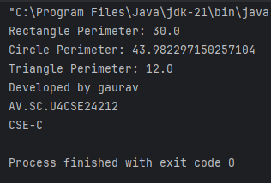

Negative Case:
Error Table:
SNO | ERROR | RECTIFICATION
1 | Negative dimensions for shapes | Added validation in constructors
Important Points:
- The Shape interface defines a contract for all shapes to implement the getPerimeter() method.
- Each shape class provides its own implementation of the perimeter calculation based on its specific properties.
- The program demonstrates polymorphism by using the Shape interface to refer to different shape objects.

2)AIM: Write a JAVA program to create an interface Playable with a method play() that takes no arguments and returns void. Create three classes Football, Volleyball and Basketball that implement the Playable interface and override the play() method to play the respective sports.
Class Diagram:

Playable

+ play (): void

Football Volleyball Basketball

+play() +play() +play()

Program:
interface Playable {
void play();
}
class Football implements Playable {
@Override
public void play() {
System.out.println("Playing Football!");
}
}
class Volleyball implements Playable {
@Override
public void play() {
System.out.println("Playing Volleyball!");
}
}
class Basketball implements Playable {
@Override
public void play() {
System.out.println("Playing Basketball!");
}
}
public class Main15 {
public static void main(String[] args) {
Playable football = new Football();
Playable volleyball = new Volleyball();
Playable basketball = new Basketball();

football.play();
volleyball.play();
basketball.play();
System.out.println("Developed by Gaurav");
System.out.println("AV.SC.U4CSE24212");
System.out.println("CSE-C");
}
}
Output:
Positive Case:
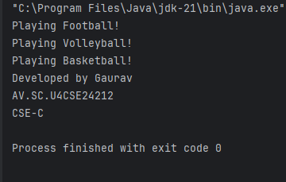

Negative Case:
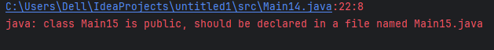

Error Table:
SNO | ERROR | RECTIFICATION
1 | Did not keep () | Kept ()

Important Points:
- The Playable interface defines a contract for any class that wants to implement the play() method.
- Each sport class (Football, Volleyball, Basketball) provides its own implementation of the play() method, demonstrating polymorphism.
- The program showcases how to use interfaces in Java to achieve abstraction and code reusability.
- This design allows for easy extension; new sports can be added by simply creating new classes that implement the Playable interface

